1.Model：SDA-TB50
2.Name：SCSI 50PIN signal adapter
3.Size：138 mm (length) x 48 mm (width)
4.Dimensions：
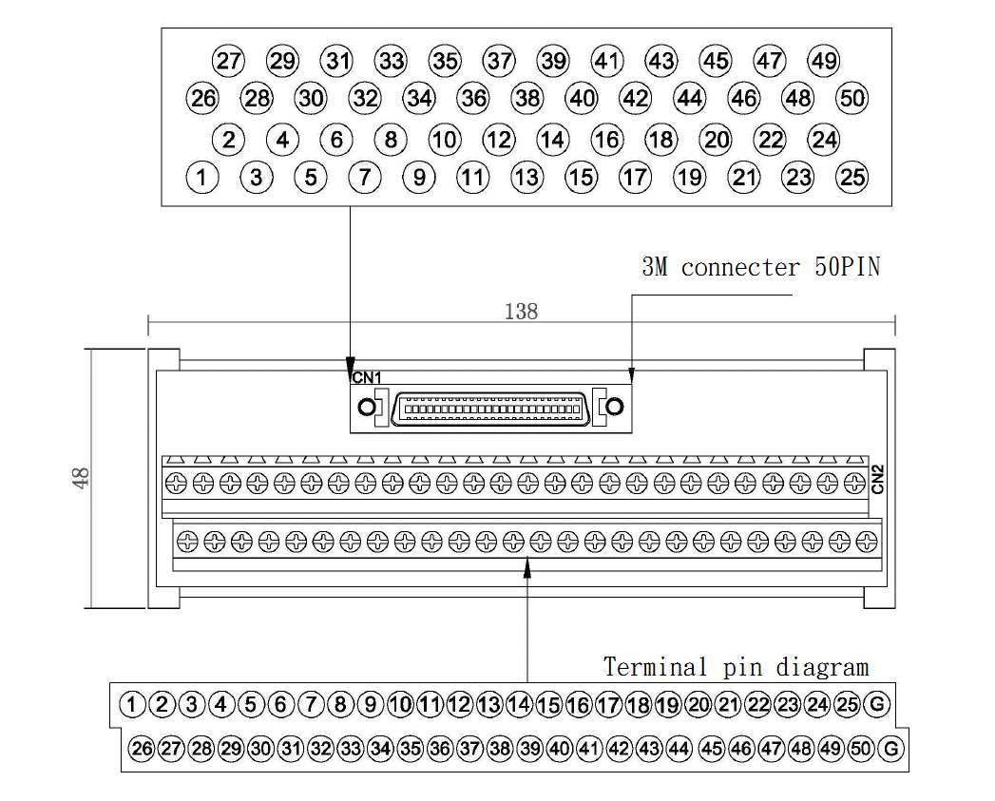
5.Wirings：SCSI to terminal
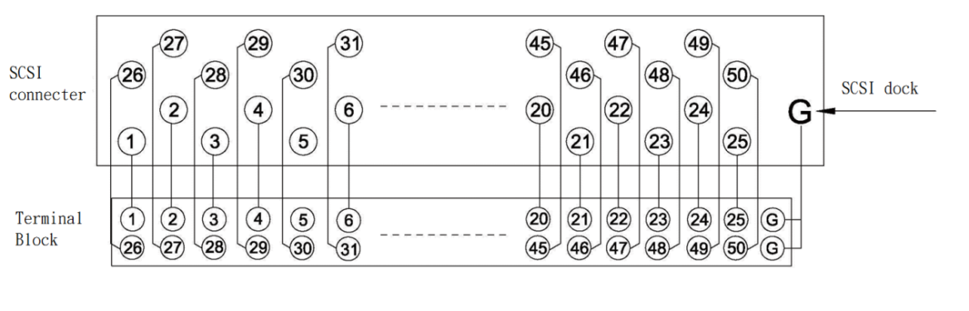
6.Compatible with：Shihlin servo
Others
To improve our products, the parameters and contents may be modified, please contact the agent or refer to Shihlin websites
(http://automation.seec.com.tw/) to download the latest version


